1. Weekly Temperature Data — Line Plot with Multiple Lines
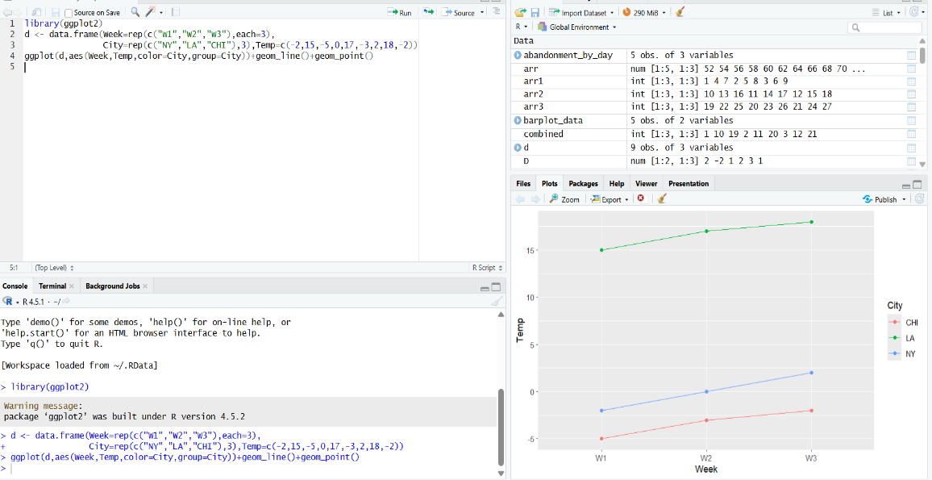
2. Social Media Engagement — Hexbin Plot
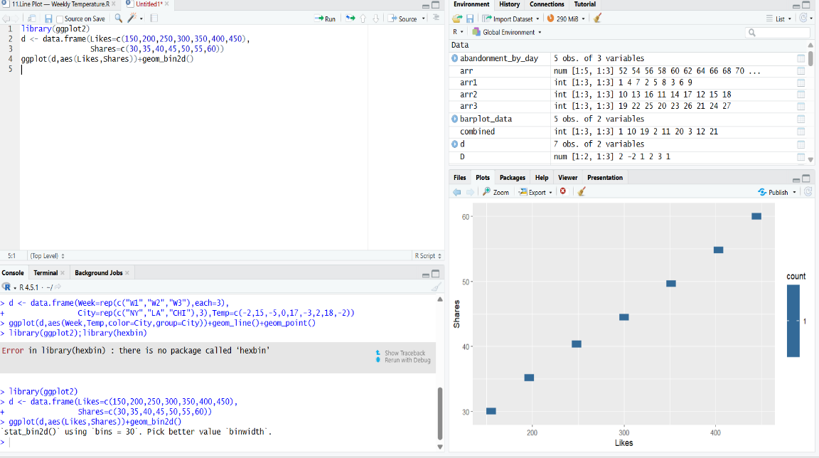
3. Sales Performance — Violin Plot
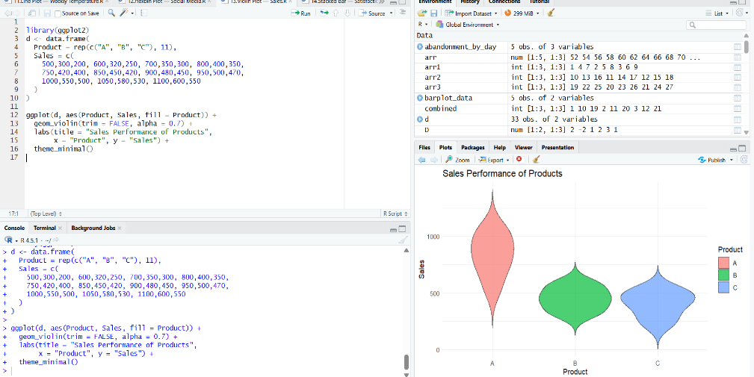

4. Customer Satisfaction — Stacked Bar Plot
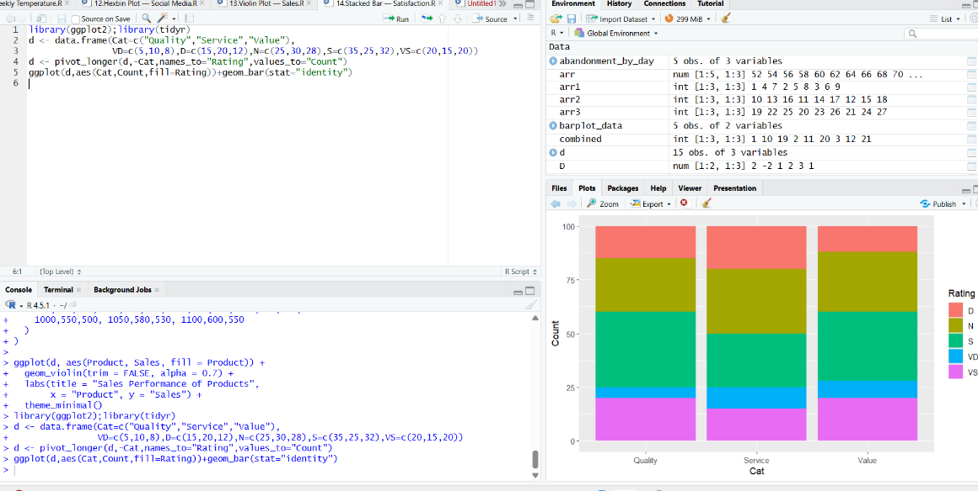
5. Employee Performance — Histogram Plot
